PROJECT REPORT
IMPORT DATA USING TRANSFORM MAPS (SPREADSHEET)
A ServiceNow-Based Employee Data Import and Management System
Submitted by: Thangamuthu S (TEAM LEAD)
Register Number: 24082021802111123
Department: Computer Science
Degree: Bachelor of Science in Computer Science
College: Aditanar college of arts and science.
Academic Year: 2026–2027

1. INTRODUCTION

1.1 Project Overview
The project titled “Import Data Using Transform Maps (Spreadsheet)” is developed using the ServiceNow platform to simplify the process of importing employee information from an external spreadsheet into a structured database. Employee data is prepared in Excel or Google Sheets and loaded into a ServiceNow Import Set table, which acts as a staging area. A Transform Map is then used to map source fields to the corresponding target table fields and transform the data into employee records.
The project also uses the Coalesce feature to identify existing employee records and update them instead of inserting duplicates. Reports and dashboards are created to present employee information by department, location, and employee details.

1.2 Purpose
- Reduce manual employee data entry during data migration.
- Import bulk employee information using ServiceNow Import Sets.
- Map spreadsheet fields to the appropriate target table fields using Transform Maps.
- Prevent duplicate employee records using Coalesce.
- Update existing employee information when changes are imported.
- Generate reports and display employee information through a centralized dashboard.

2. IDEATION PHASE

2.1 Problem Statement
Organizations often maintain employee information in spreadsheets containing employee IDs, names, email addresses, departments, and locations. Manually transferring this information into an enterprise system can be time-consuming and may result in incorrect entries, inconsistent data, and duplicate records. Repeated imports also require a mechanism to identify existing records and update them correctly.
The project addresses this problem by using ServiceNow Import Sets, Transform Maps, and Coalesce to automate employee data migration and maintain data consistency. Reports and dashboards further simplify monitoring and analysis.

2.2 Empathy Map Canvas
Category | Description
Says | Importing employee data should be simple, accurate, and quick.
Thinks | Employee information should be stored correctly without duplicates.
Does | Prepares spreadsheets, imports data, verifies records, and reviews reports.
Feels | Concerned about manual errors, repeated work, and incorrect employee information.
Pains | Manual entry, duplicate records, incorrect mapping, and difficult update tracking.
Gains | Faster imports, accurate records, reduced duplication, and easier reporting.

2.3 Brainstorming
- Prepare employee data in a structured spreadsheet.
- Create a custom Employee Test target table.
- Use an Import Set table as a staging area.
- Use a Transform Map for source-to-target field mapping.
- Use Coalesce to identify existing records and prevent duplicates.
- Create reports for department, location, and employee details.
- Combine reports into an Employee Analytics Dashboards dashboard.

3. REQUIREMENT ANALYSIS

3.1 Customer Journey map
Stage | User Activity | Challenge | Project Solution
Data Preparation | Prepare employee details in Excel | Inconsistent data | Structured spreadsheet
Data Loading | Upload spreadsheet | Manual entry takes time | Import Set table
Field Mapping | Map source and target fields | Incorrect mapping | Transform Map
Transformation | Execute transformation | Duplicates or incorrect records | Coalesce and field mapping
Validation | Check imported records | Large datasets are difficult to verify | Target table and transform history
Reporting | View employee information | Difficult to analyze | Reports
Dashboard | View consolidated reports | Information is spread across reports | Centralized dashboard

3.2 Solution Requirement
Hardware: computer or laptop, sufficient memory and storage, and stable internet connectivity.
Software: ServiceNow, Excel or Google Sheets, and a supported web browser.
- The system must accept employee information from a spreadsheet.
- The system must provide an Import Set staging table.
- The system must map source fields to target fields.
- The system must transform imported data into employee records.
- The system must identify existing records using Coalesce.
- The system must support insertion of new records and updating of existing records.
- The system must allow verification of imported data.
- The system must generate reports and display them on a dashboard.

3.3 Data Flow Diagram
Employee Excel Spreadsheet → Employee Import (Import Set) → Sample Spreadsheet Import (Transform Map + Coalesce) → Employee Test (Target Table) → Reports → Employee Analytics Dashboards.
The spreadsheet is uploaded into the Import Set table. The Transform Map maps source fields to target fields. Coalesce identifies existing employee records. The transformed records are stored in the Employee Test table and then presented through reports and the dashboard.

3.4 Technology Stack
Technology | Purpose
ServiceNow | Main platform for data import, transformation, and reporting
Import Sets | Staging area for imported spreadsheet data
Transform Maps | Map and transform source data into the target table
Coalesce | Identify existing records and prevent duplicate insertion
Custom Tables | Store employee information
Reports | Present employee information through charts and lists
Dashboards | Display multiple reports in one view
Excel / Google Sheets | Prepare the source employee dataset
Web Browser | Access ServiceNow

4. PROJECT DESIGN

4.1 Problem Solution Fit
The solution directly addresses manual data entry, repeated imports, and duplicate-record problems. The Import Set stages incoming data, the Transform Map maps source fields to target fields, and Coalesce identifies existing records for updating rather than duplicate insertion. Reports and dashboards provide a centralized view of employee information.

4.2 Proposed Solution

Spreadsheet Preparation
Prepare employee ID, name, email, department, and location in an Excel spreadsheet.

Custom Employee Table
Create Employee Test (u_employee_test) with the required fields.

Import Set
Create Employee Import (u_employee_import) as the staging table.

Transform Map
Create Sample Spreadsheet Import and configure source-to-target mappings.

Transformation and Coalesce
Execute transformation and use Coalesce to update matching records and insert new records.

Report Generation
Create Employees by Department, Employees by Location, and Employee List Report.

Dashboard Creation
Create Employee Analytics Dashboards and add all three reports.

4.3 Solution Architecture
The architecture follows a staged data-processing flow: Input Layer (Excel spreadsheet) → Import Layer (Employee Import) → Transformation Layer (Transform Map and Coalesce) → Storage Layer (Employee Test) → Presentation Layer (Reports and Dashboard). This separates loading, transformation, storage, and presentation.

5. PROJECT PLANNING & SCHEDULING

5.1 Project Planning
Phase | Activity | Expected Outcome
1 | Prepare employee spreadsheet | Structured Excel dataset
2 | Create Employee Test table | Target table with employee fields
3 | Create Employee Import table | Import Set staging table
4 | Configure Transform Map | Source-to-target mapping
5 | Transform data and configure Coalesce | Records inserted or updated
6 | Test repeated imports | Verify duplicate prevention
7 | Create reports | Department, location, and list reports
8 | Create dashboard and validate | Centralized reporting view

6. FUNCTIONAL AND PERFORMANCE TESTING

6.1 Performance Testing
Testing verifies correct data loading, field mapping, transformation, record updates, duplicate prevention, and report generation. The project documentation primarily demonstrates functional testing; quantitative execution-time or load-test measurements are not provided.
Test Case | Description | Expected Result
TC01 | Upload valid Excel spreadsheet | Data loads into Import Set
TC02 | Execute Transform Map | Employee records are created
TC03 | Verify field mapping | Values appear in correct fields
TC04 | Import modified existing IDs | Existing records are updated
TC05 | Import new IDs | New records are inserted
TC06 | Import same spreadsheet again | No duplicate records are inserted
TC07 | Generate department report | Pie chart groups by department
TC08 | Generate location report | Bar chart groups by location
TC09 | Generate employee list | Employee details appear in list
TC10 | Open dashboard | Configured reports appear together
In the documented test, four rows were uploaded in the second import: two existing employee records were updated and two new employee records were inserted. When the same spreadsheet was imported again, the documented result showed zero insertions, zero updates, and four ignored rows.

7. RESULTS
The project successfully demonstrates spreadsheet-based employee data import and reporting using ServiceNow. Employee data is loaded into the Employee Import staging table, transformed using the Sample Spreadsheet Import Transform Map, and stored in the Employee Test table. Coalesce prevents duplicate insertion by identifying matching employee records.
Three reports were created: Employees by Department, Employees by Location, and Employee List Report. These reports were added to the Employee Analytics Dashboards dashboard.

7.1 Output Screenshots
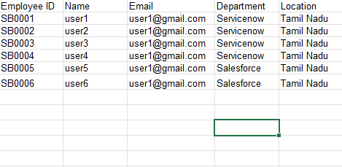

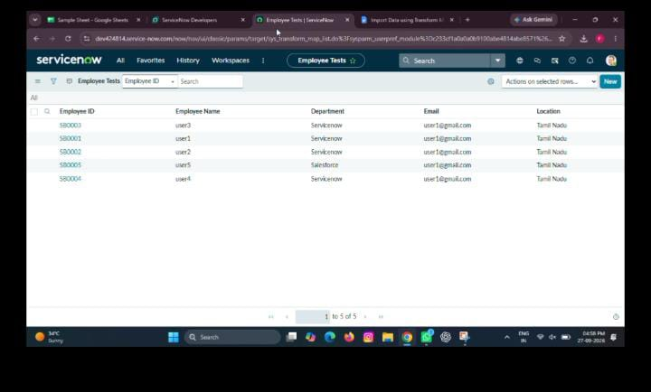

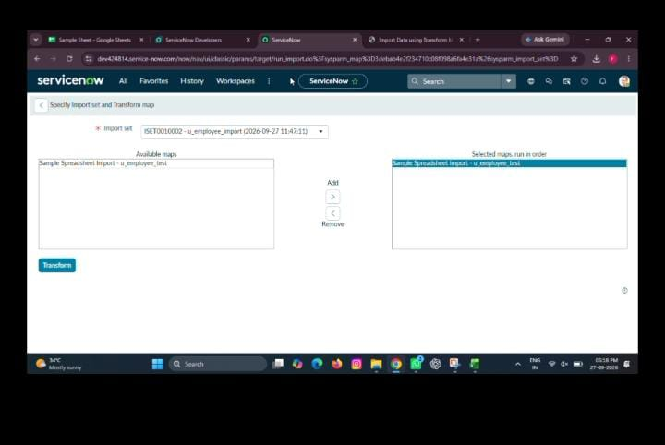

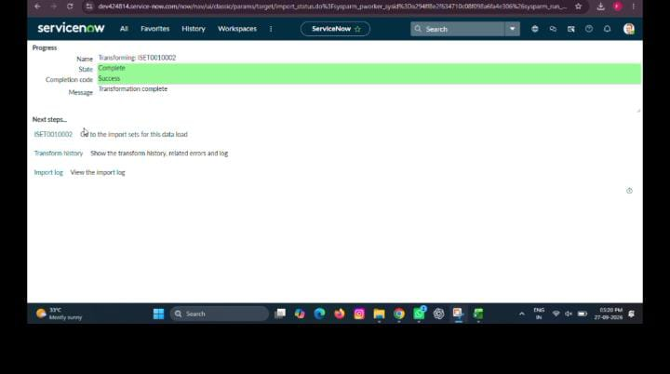

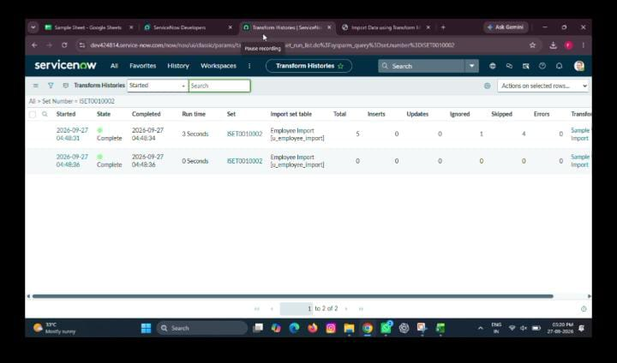

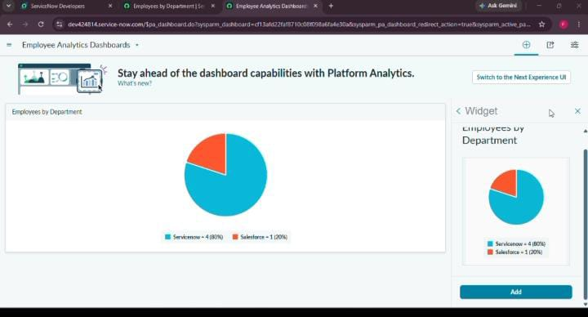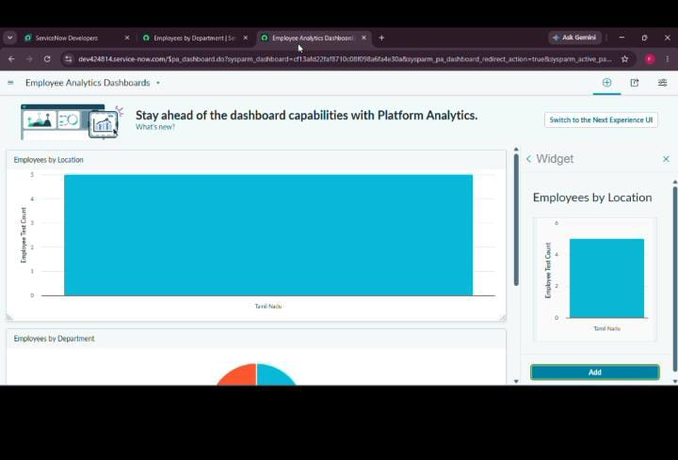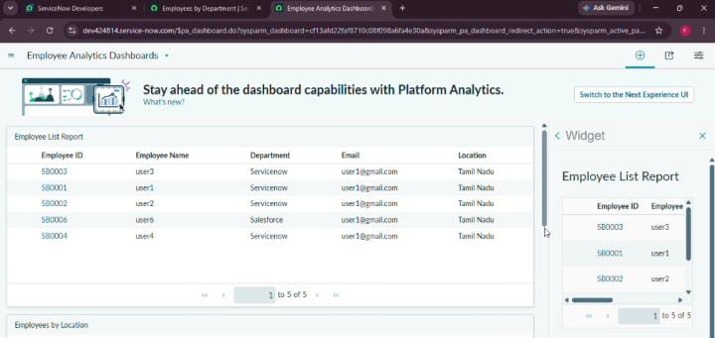

8. ADVANTAGES & DISADVANTAGES

Advantages
- Reduces manual data entry.
- Improves data consistency through field mapping.
- Prevents duplicates using Coalesce.
- Updates existing employee records.
- Provides centralized reporting.
- Provides visual charts and lists.
- Makes import verification easier.

Disadvantages
- Depends on ServiceNow access.
- Initial configuration is required.
- Incorrect spreadsheet data can affect results.
- Incorrect field mapping can cause data errors.
- Duplicate prevention depends on correct Coalesce configuration.
- User permissions can restrict configuration.
- The documented project does not include quantitative load testing.

9. CONCLUSION
The project “Import Data Using Transform Maps (Spreadsheet)” demonstrates an efficient employee data migration workflow using ServiceNow. Import Sets provide staging, Transform Maps provide field mapping, and Coalesce helps identify existing records and prevent duplicates. The documented testing showed both record insertion and update behaviour and demonstrated that repeated data could be ignored rather than inserted again. Reports and the Employee Analytics Dashboards dashboard provide organized and visual access to employee information. Overall, the project demonstrates practical use of ServiceNow data migration, transformation, validation, and reporting capabilities.

10. FUTURE SCOPE
- Automate scheduled employee spreadsheet imports.
- Add validation for missing IDs and invalid email addresses.
- Generate detailed error reports for failed records.
- Support additional data sources and integration methods.
- Add advanced employee analytics and trend reports.
- Configure role-based access controls.
- Improve import monitoring with status and record-count tracking.
- Add additional data-quality checks.

11. APPENDIX

Source Code
The project is primarily implemented through ServiceNow configuration features rather than a separately developed application codebase. The main components are Employee Test, Employee Import, Sample Spreadsheet Import, and Employee Analytics Dashboards.

